Read the dataset from the below link

https://raw.githubusercontent.com/guipsamora/pandas_exercises/master/06_Stats/US

_Baby_Names/US_Baby_Names_right.csv

Code:

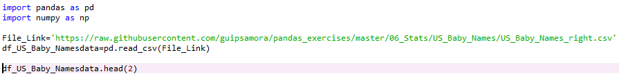

Input & Result



**1).** Delete unnamed columns

**Solution:**

Code:

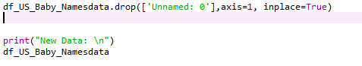

Input & Result

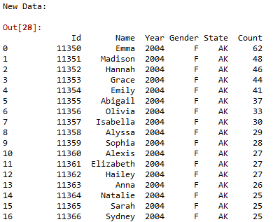

**…………**

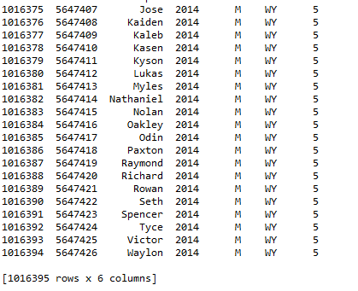

2) Show the distribution of male and female

**Solution:**

Code:



Input & Result

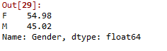

3) Show the top 5 most preferred names

**Solution:**

Code:



Input & Result

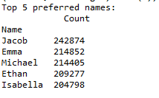

4) What is the median name occurence in the dataset.

**Solution:**

Code:



Input & Result

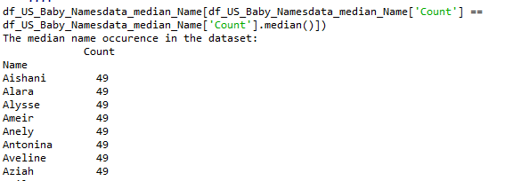

……..

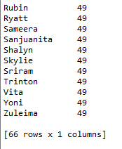

5) Distribution of male and female born count by states.

**Solution:**

Code:



Input & Result

